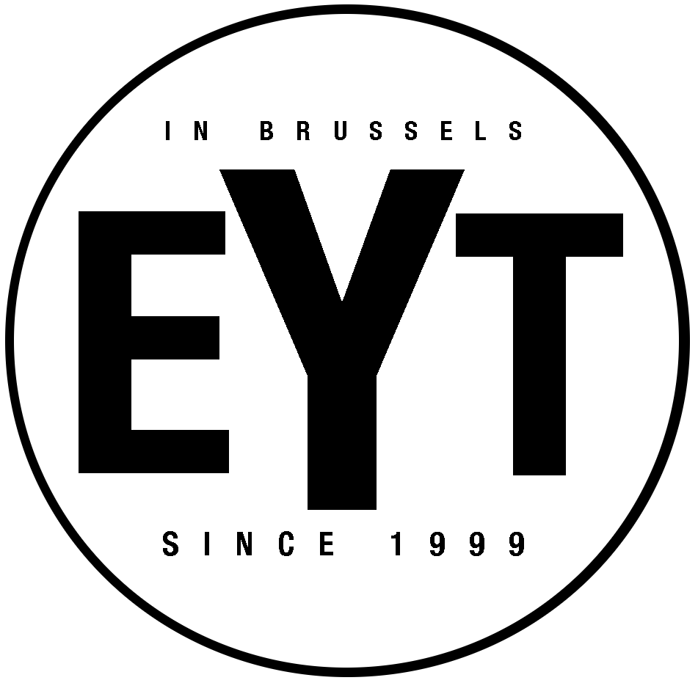
ENGLISH YOUTH THEATRE
REGISTRATION FORM 2021/22

Actor’s Details
Please let us know here of any educational needs (e.g. dyslexia) and/or medication that might be needed in class. This helps us make sure that our teaching is most effective for all students.
Family Details
Number your preferred class location in order of priority (1 to 4)

Parent Name

Address

Email
GSM

Home Tel
School

Email / GSM
Full name

Date of Birth
Ixelles (Wednesday) |  | Woluwe (Friday)
Waterloo (Thursday) |  | EU Quarter (Saturday)
Fees: 550 euros / year payable in two parts for Semesters 1 and 2
Production Levy: €50 - a one off fee covering additional costs (theatre hire, costume, rights etc) – where applicable.
Where students choose to take a LAMDA certificate, an examination fee will be payable – costs are around €60-€110 depending on the exam grade.
For the exact locations of our teaching centres, check our website: www.eyt.be
Payment details
IBAN: BE90 3631 6826 5132
The Umbrella Factory asbl

